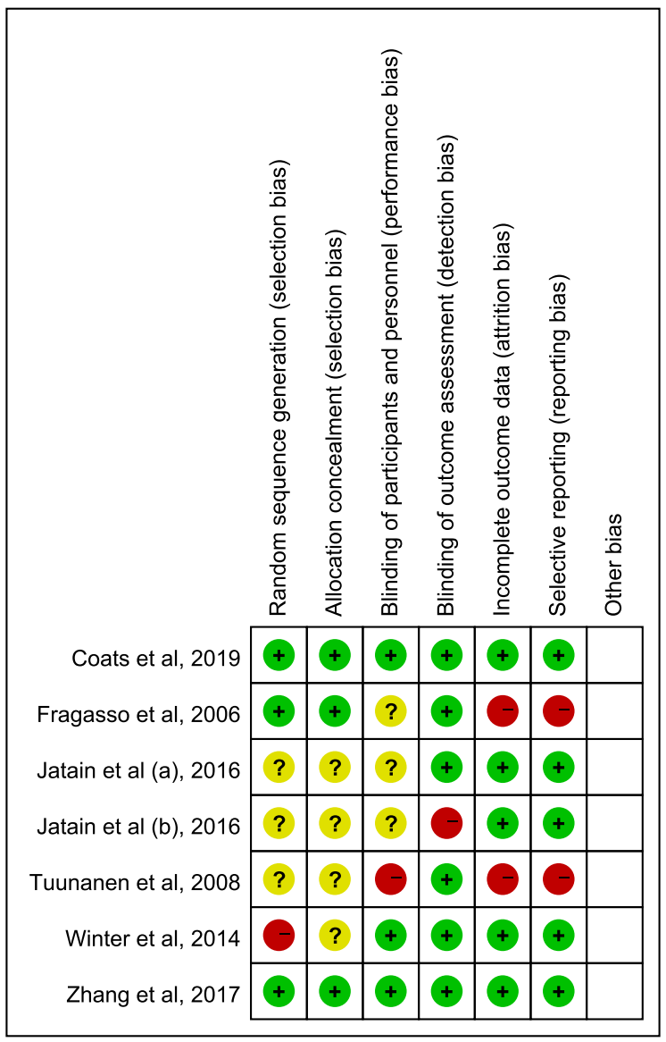
Supplementary Fig. 1. Risk score of article. ‘+’ represents low risk, ‘?’ represents unclear risk, ‘-’ represents high risk.

